Import and analyze data in Amazon Athena from AWS Glue.

# Introduction

This lab will guide you through the steps to import data into Amazon Athena using AWS Glue and then analyze that data. By the end of this lab, you will have set up a crawler in AWS Glue to catalog data stored in S3 and queried this data using Amazon Athena.

# Let’s get started

### Step 1: Log in to AWS Console

1. Open your web browser and navigate to the <https://us-west-2.console.aws.amazon.com/console/home?region=us-west-2>

2. Log in with your AWS account credentials.

### Step 2: Navigate to Athena

1. In the top navigation bar, locate the Search field.

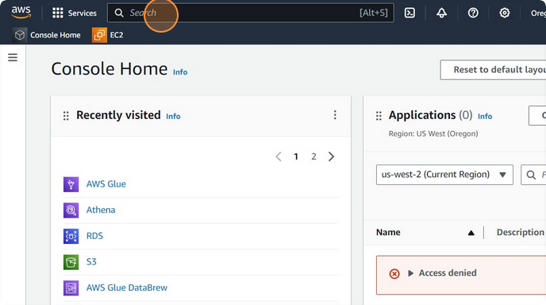

2. Type Athena in the search field and select it from the results to open the Athena service.

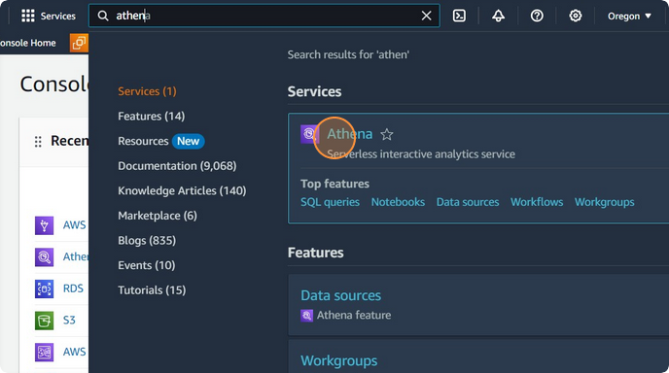

Click on Tables drop-down option.

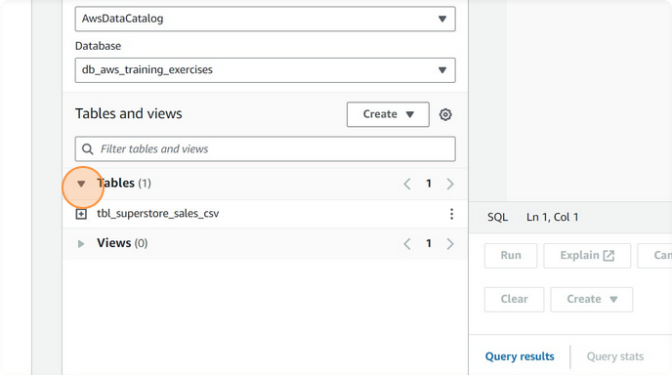

Click on 3 dot option present on the right side of the table name.

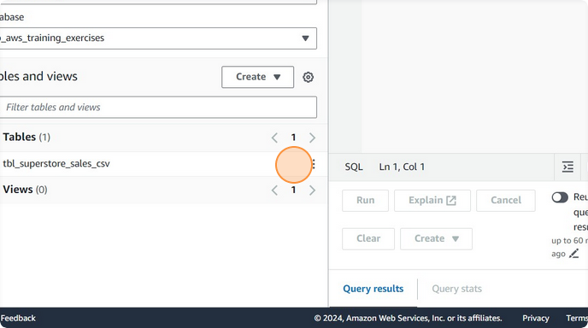

### Step 4: Preview Existing Tables

1. Click Preview Table to see a sample of data from any existing table.

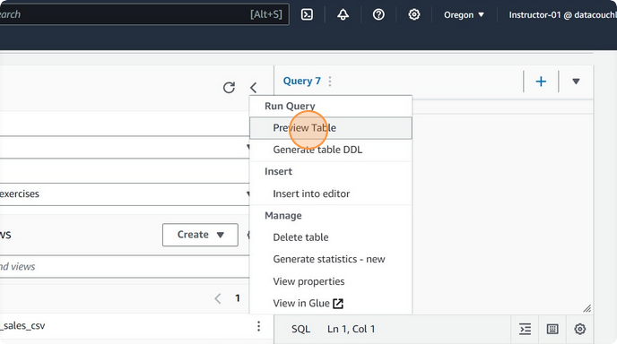

Click the query editor

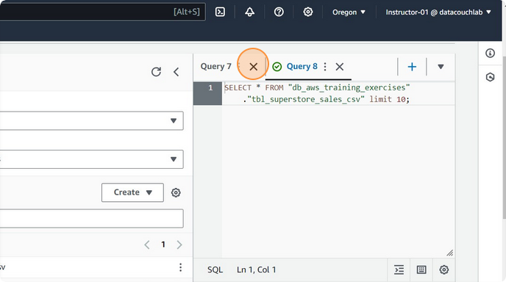

Click on "Run again"

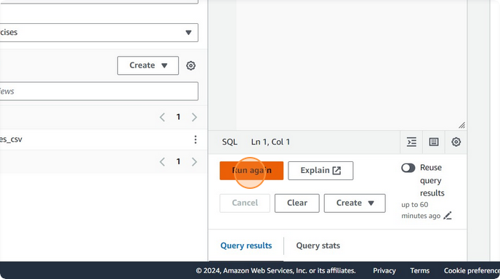

### Step 5: Navigate to AWS Glue

1. Open a new tab in your browser and navigate to the AWS Glue console by searching for AWS Glue in the AWS Management Console search bar.

2. Click AWS Glue to open the AWS Glue Dashboard.

### Step 6: Set Up a Crawler in AWS Glue

1. In the AWS Glue Dashboard, click on Crawlers in the left-hand menu.

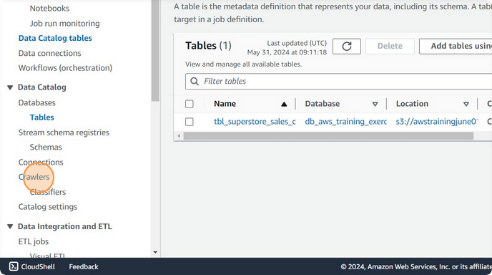

2. Click the Add crawler button.

3. Enter a name for your crawler (e.g., `crwl_Customers_Orders`).

4. Follow the wizard to configure the crawler:

- Data source: Select the S3 bucket containing your data (e.g., `s3://awstrainingjune01/Input_Data/Json/customer_orders_with_addresses.json`).

- IAM Role: Choose an existing IAM role or create a new one that has the necessary permissions to access your S3 bucket.

- Output: Specify the AWS Glue database where the crawler will create the table.

### Step 7: Run the Crawler

1. Once the crawler is set up, go back to the Crawlers section in the AWS Glue console.

2. Select the crawler you just created (`crwl_Customers_Orders`).

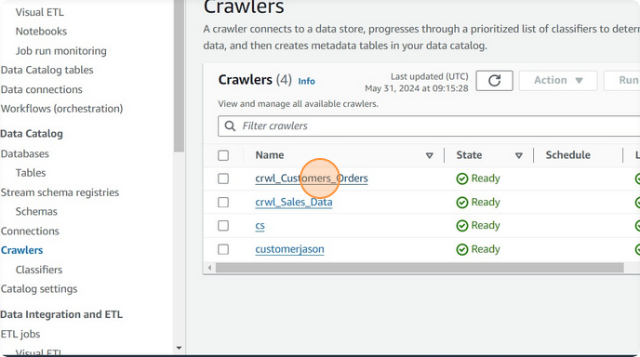

3. Click the Run crawler button.

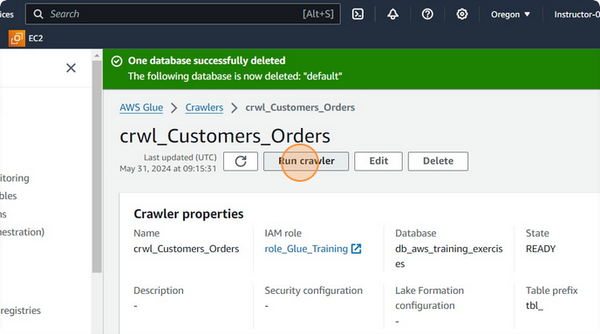

4. Wait for the crawler to complete its run. This might take a few minutes.

### Step 8: Verify Table Creation

1. After the crawler has finished running, go to the Tables section in the AWS Glue console.

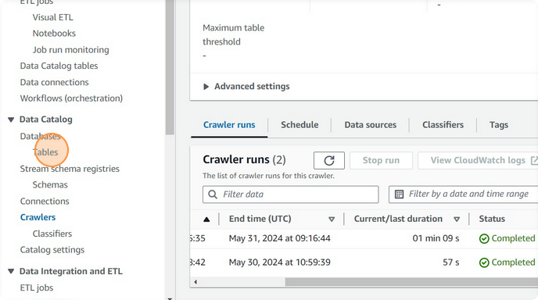

2. Verify that a new table corresponding to your data has been created.

### Step 9: Query Data in Athena

1. Go back to the Athena console.

2. In the Query editor, click Refresh to see the new table created by the crawler.

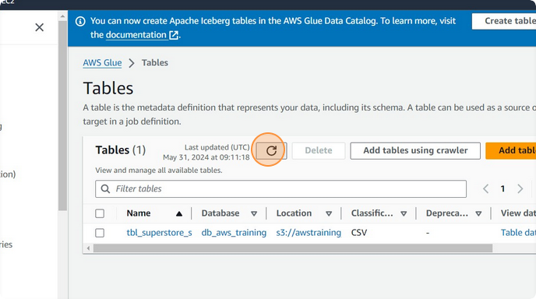

3. Select the database and table, then write and execute SQL queries to analyze your data.

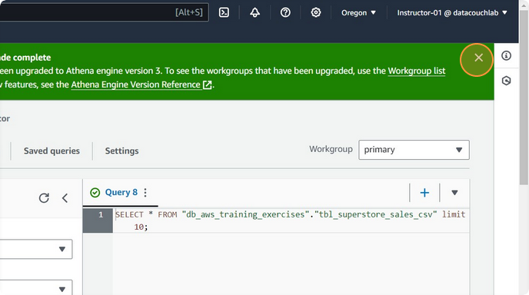

### Step 10: Preview Table in Athena

1. Click the Preview Table button to see a sample of data from the newly created table.

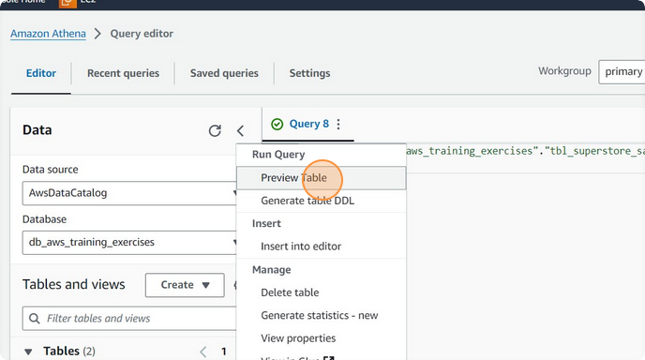

2. Use the Run query button to execute your queries and view results.

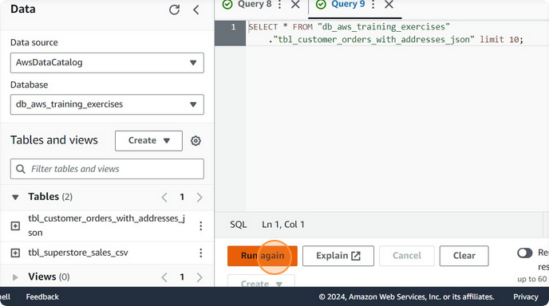

**Voila!!** We have successfully completed this exercise.